**PHYSICS ENVIRONMENTAL LITERACY LESSON**

**GARRETT COUNTY, MARYLAND**

**Composed by:**

**Derek Berger, Northern Garrett High School, 2011**

**Generously Supported by:**

**Blue Moon Rising**

**Garrett Container Systems, Inc.**

**Railey Realty**

**PHYSICS ENVIRONMENTAL LITERACY LESSON**

**(Student Edition)**

**GARRETT COUNTY, MARYLAND**

**Generously Supported by:**

**Blue Moon Rising Center for Sustainable Education**

**Garrett Container Systems, Inc.**

**Railey Realty**

**OVERVIEW**

This activity was designed with the intent of satisfying the State of Maryland Environmental Literacy Graduation Requirement for those students who take any or all physics classes in Garrett County, Maryland. It also is designed as a STEM lesson following the 5E Model for instruction.

**OBJECTIVES**

The lesson has the following objectives:

* Students will be able to explain factors that influence global temperature and climate change and how human activity plays a role in these changes.
* Students will investigate sustainable (green) sources of energy production, in particular wind energy that may reduce harmful effects of climate change, both locally and globally.
* Students will understand how the wind energy can be harnessed and converted into “clean” electricity.

**ACTIVITIES**

The objectives will be met by conducting a full day of activities at the Hickory Environmental Education Center (HEEC) and then following up with classroom activities. These activities include:

* HEEC Planetarium ViewSpace “Is Earth Thawing?”
* Global Warming and Atmospheric CO2
* Wind Energy
* Viability of Wind Energy at HEEC
* Wind Turbines in Garrett County – You Decide!

**ALTERNATE ACTIVITY**

Students who do not participate in the ELP Lesson at HEEC will be required to complete the following activities at their school:

* Global Warming and Atmospheric CO2
* Wind Energy
* Wind Turbines in Garrett County – You Decide!

**Activity 2: Global Warming and Carbon Dioxide**

**PURPOSE**

* Research carbon dioxide concentrations in the atmosphere for the last 420,000 years
* Correlate the data mathematically to global temperature

**MATERIALS**

* Internet access
* MS Excel or similar spreadsheet software
* Printer

**PRELIMINARY ACTIVITY**



The Keeling Curve to the right shows the variation in concentration of atmospheric carbon dioxide since 1958. It is based on continuous measurements taken at the Mauna Loa Observatory in Hawaii under the supervision of Dr. Charles Keeling of the Scripps Institution of Oceanography in San Diego. Keeling's measurements beginning in 1958, showed the first significant evidence of rapidly increasing carbon dioxide levels in the atmosphere. Additional measurements by scientists working at NOAA have extended the Keeling Curve from 1974-2006.

Atmospheric scientists measure the concentration of gases in terms of parts-per-million (ppm).One ppm = 1 particle out of 1

million particles in a sample. It also represents a

percentage: ppm/1million x 100%.

1. In the graph, what was the concentration of carbon dioxide in 2005?

2. What percentage of Earth's atmosphere, by volume, was carbon dioxide gas in 2005?

3. If a concentration of 127 ppm of carbon dioxide in the atmosphere equals a total of

1,000 gigatons of carbon dioxide (1,000 billion tons), about what was the total mass of carbon dioxide gas in 2005?

4. How many additional gigatons of carbon dioxide were added to the atmosphere

between 1958 and 2005?

5. What was the average rate of increase of carbon dioxide gas in gigatons per year

between 1958 and 2005?

6. The seasonal change in carbon dioxide is shown by the 'wavy' shape of the line. What

is the width of this wave (range from maximum to minimum) in ppm, and about how many gigatons does this natural change correspond to?

**PROCEDURE**

1. Select a reasonable interval of time for data point selection for the last 420,000 years and record it below.
2. Go to the following website and enter the years and the CO2 concentrations in a MS Excel spreadsheet:

<http://cdiac.esd.ornl.gov/ftp/trends/co2/vostok.icecore.co2>

1. Go to the following website and enter the years and temperatures in a spreadsheet:

<http://cdiac.esd.ornl.gov/ftp/trends/temp/vostok/vostok.1999.temp.dat>

The age of the core samples is in column 2 and the temperature is in column 4.

1. From the spreadsheets, make two graphs. On the first graph, plot before present time on the x-axis and CO2 concentration on the y-axis. On the second graph plot before present time on the x-axis and temperature variation on the y-axis. Print or sketch a copy of each graph.
2. Analyze your data/graphs.
   1. Describe how carbon dioxide concentrations and temperatures vary over time.
   2. How do the changes on each graph compare to one another? Is there evidence of a cause-and-effect relationship between CO2 and temperature? Explain.
   3. Where are we today in terms of CO2 concentration in relation to the graphed data? What lies in the near future in terms of global temperature change? What in the data makes you believe that change?

**Activity 3: Wind Energy**

**INTRODUCTION**

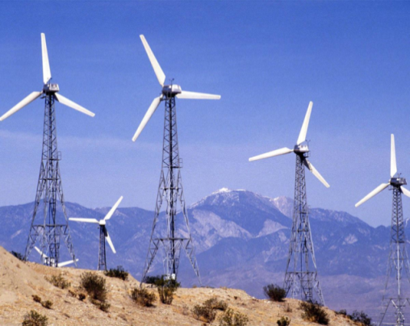Power from the wind has become an increasingly popular option for electricity generation. Unlike traditional energy sources such as coal, oil, and gas that contribute large quantities of carbon dioxide to the atmosphere, wind power relies on a non-polluting, renewable, ever-present resource—the wind. In recent years, the cost of harnessing energy from the wind has become more affordable making it a viable alternative for many communities.

A wind turbine generally consists of a two- or three-bladed propeller made of aluminum or fiberglass mounted on the top of a tall tower. It converts energy from the mechanical energy of moving air to electrical energy by means of a generator. The wind causes the shaft of the turbine to spin which in turn causes a generator to produce electricity.

**PURPOSE**

In this activity, you will determine the power output of a wind turbine that you build. You will use a small motor as a generator and a pinwheel as the turbine. The power output of the pinwheel can be determined by measuring the current and voltage produced by the motor. Power is determined using the relationship

*P = V I*

Power = voltage × current

Where power has units of watts (W), voltage has units of volts (V), and current has units of amperes (A).

**MATERIALS**

* Scissors
* Single hole punch (1/8 in.)
* 3 wire leads with alligator clips
* 1.0 Ω resistor
* Ruler
* 1.5 V DC motor
* LabQuest interface
* Current probe
* Voltage probe
* Stand, rod, clamp
* Fan
* Pinwheel templates on cardstock paper
* Cocktail drinking straw

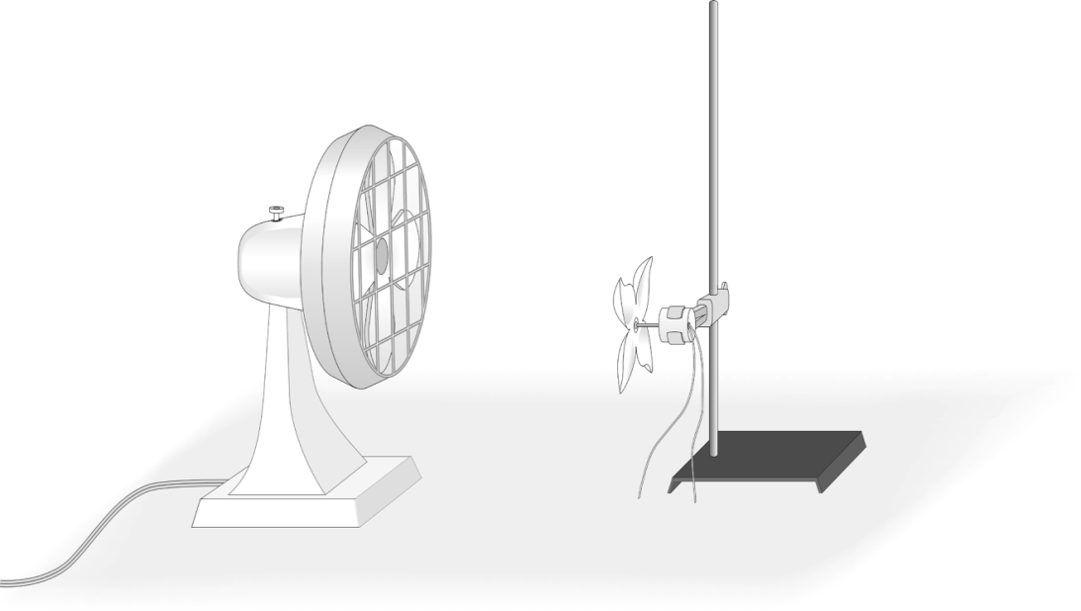

**Figure 1**

**Figure 2**

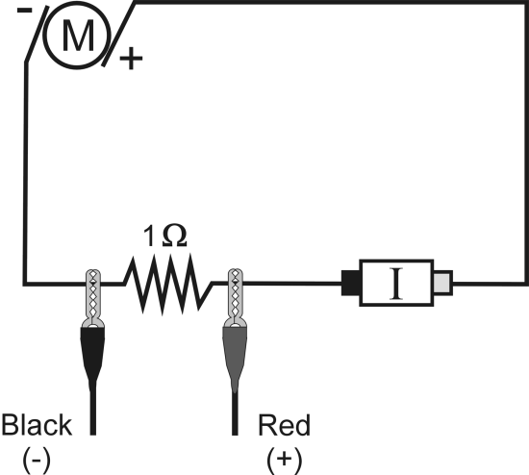

**PROCEDURE**

1. Cut out the square pinwheel design by cutting along all of the lines on the template. Cut out the hole in the center of the pinwheel and on the end of each of the blades using the 1-hole punch. Push the straw through the center of the pinwheel. Carefully bring each of the blades in toward the center of the pinwheel and thread the straw through each of the blades. Be careful not to tear the paper. Place a bit of clay on the end of the straw to keep the blades from spinning off the straw. Put a piece of tape or a plastic tubing clamp on the straw behind the pinwheel to keep the paper from sliding.

2. Put the propeller shaft adapter on the shaft of the motor. Insert the propeller shaft adapter into the end of the straw. You may wish to use a plastic tubing clamp to secure the straw to the shaft. Secure the motor to the ring stand using a utility clamp as shown in Figure 1.

3. Connect a Current Probe and a Voltage Probe to Ch1 and Ch2 of the LabQuest.

4. Connect the motor, 1-Ω resistor, wires, and clips as shown in Figure 2. Take care that the red lead from the motor and the red terminal of the Current Probe are connected.

5. Since the direction of spin of the pinwheel depends on its design, you will need to check to see that both the current and voltage readings are positive.

1. Blow on the pinwheel.
2. Look at the live readouts and note whether either reading is negative or zero.
3. If the current reading is negative, disconnect the alligator clips from the wires on the motor and switch them.
4. If the voltage reading is negative or zero, unclip the voltage probe clips and switch them.



6. On the LabQuest, select the Data Collection tab and zero both probes by choosing <Zero> from the Sensor menu. This sets the zero for both probes with no current flowing and no voltage applied.

7. Place the pinwheel about 15 cm in front of the fan. Turn on the fan to the high setting. Wait for 60 seconds until the fan reaches a constant velocity.

8. Start data collection.

9. Stop data collection after about 30 seconds.

10. Select the Graph tab and determine the mean current and mean voltage readings. To do this, drag the stylus to highlight the region of data you wish to analyze. Then choose <Statistics> from the Analyze menu. Record these values under Trial 1 the table below.

11. Repeat steps 7 – 10 above for two more trials. Determine the average current and average voltage produced by the wind turbine.

|  |  |  |
| --- | --- | --- |
| Trial | Current (Amps) | Voltage (Volts) |
| 1 |  |  |
| 2 |  |  |
| 3 |  |  |
| Mean |  |  |

**QUESTIONS and EXTENSION**

1. Calculate the average power output of the turbine (in W) based on your data using the equation given in the introduction above.
2. Using your knowledge of the law of conservation of energy, explain all of the energy transfers that occur as the wind energy is converted to electrical energy by a wind turbine.
3. Many factors influence the power generated by a wind turbine, including wind speed and propeller shape. Develop a testable hypothesis related to each of these factors. Then, develop a plan to investigate your hypotheses and collect the necessary data to determine if your hypothesis is correct. Be sure to document your hypothesis, methods, data collected and your conclusions.
4. What are some characteristics of an ideal location to build a *wind farm*, a grouping of many wind turbines? What makes these characteristics ideal?

**Activity 4: Viability of Wind Energy at the Hickory Environmental Education Center**

**INTRODUCTION**

Wind can be used to generate electricity. Before that power can be harnessed to generate electricity, wind speed has to be determined. If the speed is not fast enough to generate electricity, then it may not be an ideal location for a wind turbine. The lowest speed that will allow a given wind turbine to generate usable amounts of energy is known as the “cut-in speed.” On average, the wind needs to supply a constant wind speed of 6.21 m/s (13.9 mph) for an industrial wind turbine to generate electricity. Wind speed is measured using a tool called an anemometer. The anemometer records the number of revolutions per unit of time and then converts it into speed in m/s or mph.

**PURPOSE**

In this activity, you will determine the wind speeds at several locations near the Hickory Environmental Education Center (HEEC) and determine what site, if any, would be viable for the installation of a residential wind turbine.

**MATERIALS**

* LabQuest interface
* Vernier anemometer

**PROCEDURE**

1. Visit the following website:

<http://www.cascaderenewableenergy.com/swift-wind-turbine.com>.

There you will find the technical specifications for the Swift® residential wind turbine. Scan the page to find the cut-in speed required to operate the turbine and place the value below.

|  |
| --- |
| Residential Wind Turbine Cut-in Speed (m/s): __________________________ |

1. Plug the anemometer into Ch1 of LabQuest interface. In order to ensure that the device is working properly, press <Start> on the data collection screen of the LabQuest and gently blow air into the anemometer. Once you are getting readings, stop data collection and clear the data.
2. Visit each of the 5 predetermined possible wind turbine sites near HEEC. At each location, perform each of the following:
   1. Using the anemometer, collect approximately 2 minutes of wind speed data. Once you have the data, highlight the data and use the statistics functions of the LabQuest to determine the mean wind speed at each location. Record the average wind speeds in the table below.
   2. Note the qualitative characteristics (elevation, surroundings, etc.) of each site and note how this may affect wind speed.

|  |  |  |
| --- | --- | --- |
| Site | Mean Wind Speed (m/s) | Notes/Characteristics |
| A |  |  |
| B |  |  |
| C |  |  |
| D |  |  |
| E |  |  |

1. In the space below describe the overall weather conditions for today (i.e. clear/cloudy, calm/storm, strong/weak winds, etc.).

1. Once you have visited each site and recorded your data and observations, return to the HEEC cafeteria.

**QUESTIONS**

1. What was the highest average wind speed that you recorded? Which site had the highest average wind speed?
2. Based on the cut-in speed that you found, do you support or refute the idea that wind is a viable source of power at the HEEC? Use your data and observations to support your claim.
3. Based on your experiences today, what are some advantages of using wind power over power from traditional means such as fossil fuels? What are some disadvantages?

**Activity 5: Wind Turbines in Garrett County – You Decide!**

**INTRODUCTION**

In 2009, after years of planning, Maryland's first commercial wind energy project broke ground in Garrett County. As of 2011 there were 28 wind turbines along Backbone Mountain, southeast of the town of Oakland, Maryland. As with many public land projects, there were strong opinions on both sides of the debate as to whether or not to allow the wind power industry into the mountains of Maryland.

**OBJECTIVE**

Write an argumentative essay explaining your position regarding the building and operation of wind turbines in Garrett County. Remember this is a genre of writing that requires the student to investigate the topic, collect, generate, evaluate evidence, and establish a position on the topic in a concise manner.

Your essay must:

* include at least ***three cited sources of information to support your position*** and at ***least three cited sources of information that refute*** the claims of the other side and;
* be at least ***2 full word processed pages*** in length

**PHYSICS ENVIRONMENTAL LITERACY LESSON**

**(Teacher Edition and Key)**

**GARRETT COUNTY, MARYLAND**

**OVERVIEW**

This activity was designed with the intent of satisfying the State of Maryland Environmental Literacy Graduation Requirement for those students who take any or all physics classes in Garrett County, Maryland. It also is designed as a STEM lesson following the 5E Model for instruction.

**OBJECTIVES**

The lesson has the following objectives:

* Students will be able to explain factors that influence global temperature and climate change and how human activity plays a role in these changes.
* Students will investigate sustainable (green) sources of energy production, in particular wind energy that may reduce harmful effects of climate change, both locally and globally.
* Students will understand how the wind energy can be harnessed and converted into “clean” electricity.

**ACTIVITIES**

The objectives will be met by conducting a full day of activities at the Hickory Environmental Education Center (HEEC) and then following up with classroom activities. These activities include:

* HEEC Planetarium ViewSpace “Is Earth Thawing?”
* Global Warming and Atmospheric CO2
* Wind Energy
* Viability of Wind Energy at HEEC
* Wind Turbines in Garrett County – You Decide!

**ALTERNATE ACTIVITY**

Students who do not participate in the ELP Lesson at HEEC will be required to complete the following activities at their school:

* Global Warming and Atmospheric CO2
* Wind Energy
* Wind Turbines in Garrett County – You Decide!

**Physics ELP Lesson Plan**

| **5E Lesson Components** | **Description of Activity** |
| --- | --- |
| **Engagement**  The activities in this section capture the participants’ attention, stimulate their thinking, and help them access prior knowledge. | Location: HEEC Planetarium  Activities: (1)Video - ViewSpace “Is Earth Thawing?” |
| **Exploration**  In this section, participants are given time to think, plan, investigate, and organize collected information. | Location: HEEC Cafeteria  Activities: (2) Global Warming and Atmospheric CO2,(3) Wind Energy |
| **Explanation**  Participants are now involved in an analysis of their exploration. Their understanding is clarified and modified because of reflective activities. | Location: HEEC Cafeteria  Activities: (3) Wind Energy |
| **Extension**  This section gives participants the opportunity to expand and solidify their understanding of the concept and/or apply it to a real world situation. | Location: HEEC, School-based physics classrooms  Activities: (4) Viability of Wind Energy at HEEC, (5) Wind Turbines in Garrett County – You Decide! |
| **Evaluation**  Evaluation occurs throughout the lesson. Scoring tools developed by teachers and participants target what participants must know and do. Consistent use of scoring tools improves learning. | Activity 2: Students will submit graphs and answers to the questions for evaluation.  Activity 3: Students will submit completed lab sheets for evaluation. Question and extension #3 will be assessed with a scientific inquiry rubric developed by the Oregon State Dept. of Education.  Activity 4: Students will submit completed lab sheets for evaluation.  Activity 5: Student written responses will be collected and evaluated using the Garrett County High School College and Career Readiness Rubric. |

| **Standard** | **Standard Number (s)** | **Activity** |
| --- | --- | --- |
| **Maryland Environmental Literacy Standards** | 1.A.4, 1.A.5, 1.B.2, 3.A.3, 5.A.2, 5.B.1, 7.B.1, 7.C.1, 7.D.1 | All |
| **Common Core Standard for Mathematical Practice** | SMP1, SMP3, SMP4, SMP5, SMP6, SMP7 | Activity 2, Activity 3 |
| **International Technology Education Association Standards for Technological Literacy** | S3J, S4I, S5G, S5H, S5K, S5L, S12P, S16J, S16K, S16M | Activity 2, Activity 3, Activity 4 |
| **Common Core Reading Standards for Literacy in Science and Technical Subjects** | KID2, IKI7, IKI9 | Activity 5 |
| **Common Core Writing Standards for Literacy in History/ Social Studies, Science and Technical Subjects** | TTP1a, TTP1b, TTP1d, TTPe, RBPK7, RBPK9 | Activity 5 |
| **Maryland Science Skills and Processes Standards** | 1.1.2, 1.2.1, 1.2.3, 1.2.4, 1.2.5, 1.3.1, 1.3.2, 1.3.4, 1.4.1, 1.4.2, 1.4.6, 1.4.8, 1.4.9, 1.5.3, 1.5.9, 1.6.1, 1.7.1, 1.7.2 | Activity 2, Activity 3, Activity 4 |

**Materials List**

**(supplies 6 groups of 2 – 4 students, up to 24 total)**

|  |  |  |
| --- | --- | --- |
| **Activity** | **Item** | **Qty Required** |
| 2 | Computers w/ Internet and MS Excel | 6 |
| 3 | Computer w/ Projector and Speakers | 1 |
| 3 | Small "A" Base (Stand) | 6 |
| 3 | Rods (45 cm) | 6 |
| 3 | Utility Clamp | 6 |
| 3 | Wire Leads (w/ alligator clips) | 18 |
| 3 | DC Motor (1.5 - 3.0 V) | 6 |
| 3 | 1 Ohm/10W Resistor | 6 |
| 3 | Extension Cord | 6 |
| 3 | Power Strip | 3 |
| 3 | 3 Speed Fan | 6 |
| 3 | Cocktail Drinking Straws | 12 |
| 3 | Single Hole Punch (1/8 in) | 6 |
| 3 | Scissors | 6 |
| 3 | Metric Ruler | 6 |
| 3 | Cardstock Paper (w/ prop templates) | 12 |
| 3 | Voltage Probe | 6 |
| 3 | Current Probe | 6 |
| 3,4 | LabQuest | 6 |
| 4 | Anemometer | 6 |

Teachers may also want to have hard copies and digital copies of the following:

1. CO2 and temperature data from Vostok ice cores (Activity 2)
2. Nasa Video “Piecing Together the Temperature Puzzle” (Activity 3)

**Activity 2: Global Warming and Carbon Dioxide**

**PURPOSE**

* Research carbon dioxide concentrations in the atmosphere for the last 420,000 years
* Correlate the data mathematically to global temperature

**MATERIALS**

* Internet access
* MS Excel or similar spreadsheet software
* Printer

**PRELIMINARY ACTIVITY**



The Keeling Curve to the right shows the variation in concentration of atmospheric carbon dioxide since 1958. It is based on continuous measurements taken at the Mauna Loa Observatory in Hawaii under the supervision of Dr. Charles Keeling of the Scripps Institution of Oceanography in San Diego. Keeling's measurements beginning in 1958, showed the first significant evidence of rapidly increasing carbon dioxide levels in the atmosphere. Additional measurements by scientists working at NOAA have extended the Keeling Curve from 1974-2006.

Atmospheric scientists measure the concentration of gases in terms of parts-per-

million (ppm).One ppm = 1 particle out of 1

million particles in a sample. It also represents

a percentage: ppm/1million x 100%.

1. In the graph, what was the concentration of carbon dioxide in 2005?

About 379 ppm

2. What percentage of Earth's atmosphere, by volume, was carbon dioxide gas in 2005?

379 ppm = 379/1000000 x 100 = .0379%

3. If a concentration of 127 ppm of carbon dioxide in the atmosphere equals a total of

1,000 gigatons of carbon dioxide (1,000 billion tons), about what was the total mass of carbon dioxide gas in 2005?

379 ppm (1000 gigatons/127ppm) = 2984 gigatons = 2980 gigatons with sig figs.

4. How many additional gigatons of carbon dioxide were added to the atmosphere

between 1958 and 2005?

In 1958 there were 315ppm, so in 2005 it had gained 64ppm. So, 64 ppm (1000 gigatons/127 ppm) = 500 gigatons

5. What was the average rate of increase of carbon dioxide gas in gigatons per year

between 1958 and 2005?

500 gigatons/47 years = 11 gigatons/year

6. The seasonal change in carbon dioxide is shown by the 'wavy' shape of the line. What

is the width of this wave (range from maximum to minimum) in ppm, and about how many gigatons does this natural change correspond to?

Answer: Using a metric ruler and estimating the peak to peak variation of the amplitude, students should get about 5 ppm as the range. This equals (5 ppm/127 ppm) x 1,000 gigatons = 39 gigatons.

**PROCEDURE**

1. Select a reasonable interval of time for data point selection for the last 420,000 years and record it below.

Every 10,000 years.

1. Go to the following website and enter the years and the CO2 concentrations in a spreadsheet:

<http://cdiac.esd.ornl.gov/ftp/trends/co2/vostok.icecore.co2>

1. Go to the following website and enter the years and temperatures in a spreadsheet:

<http://cdiac.esd.ornl.gov/ftp/trends/temp/vostok/vostok.1999.temp.dat>

The age of the core samples is in column 2 and the temperature is in column 4.

1. From the spreadsheets, make two graphs. On the first graph, plot before present time on the x-axis and CO2 concentration on the y-axis. On the second graph plot before present time on the x-axis and temperature variation on the y-axis. Print or sketch a copy of each graph.

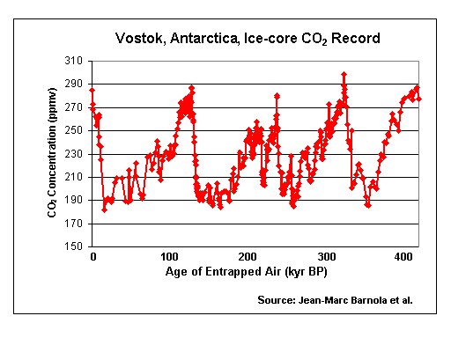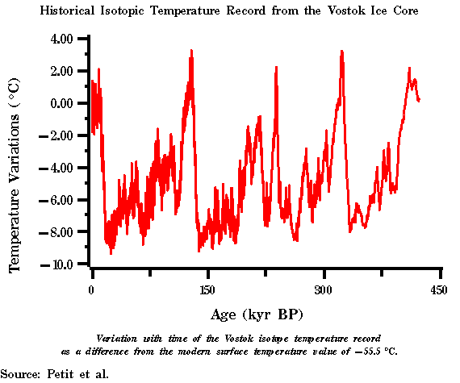

1. Analyze your data and graphs.
   1. Describe how carbon dioxide concentrations and temperatures vary over time.

CO2 and temperature both vary in a somewhat cyclic manner through time. The peak CO2 value has never exceeded approx. 300 ppm and the temperature has never exceeded a +3.2°C change.

* 1. How do the changes on each graph compare to one another? Is there evidence of a cause-and-effect relationship between CO2 and temperature? Explain.

As CO2 increases there is a corresponding temperature increase, and as CO2 decreases the temperature decreases. Furthermore, the greater the

CO2 increase/decrease the more the temperature change.

* 1. Where are we today in terms of CO2 concentration in relation to the graphed data? What lies in the near future in terms of global temperature change? What in the data makes you believe that change?

According to the Keeling Curve, we are currently at approximately 385 parts-per-million. Sharp rise in global temperature to correltate with rise in CO2 .

**Activity 3: Notes and Tips**

**TRANSITION FROM 2 to 3:** VIDEO “Piecing Together the Temperature Puzzle” found at: <http://climate.nasa.gov/ClimateReel/video/Temperature_Puzzle_640x360.cfm>

Last line of the movie is the motivation for Activity 3.

**NOTES and TIPS**

1. This activity is written for a Vernier Voltage Probe and a Current Probe. It can also be done using a Differential Voltage Probe or the Voltage Probe from a Current & Voltage System, and a Current Probe or the Current Probe from a Current and Voltage System.
2. To tell if the Voltage Probe is working properly, connect the sensor to the interface and start the data-collection program. Use wire leads to connect the probe to a DC battery of known voltage.
3. To tell if the Current Probe is working properly, connect the sensor to the interface and start the data-collection program. Use wire leads to connect the probe to a DC supply with a known resistance. Use a voltage probe or voltmeter to measure the voltage. Compare the measured current against the theoretical reading. A DC battery and single resistor should work for this test.
4. Pin wheels made of cardstock work far better than regular paper.
5. Sample data was collected using a 1.5 – 3.0 V DC motor from Radio Shack.
6. The resistor should be a 1Ω 10W resistor.

**Activity 3: Wind Energy**

**INTRODUCTION**

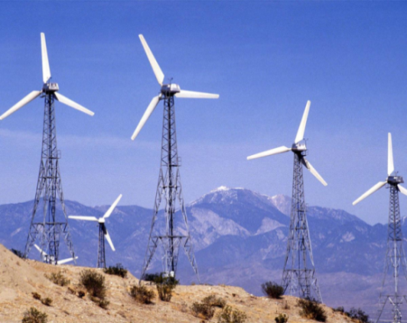Power from the wind has become an increasingly popular option for electricity generation. Unlike traditional energy sources such as coal, oil, and gas that contribute large quantities of carbon dioxide to the atmosphere, wind power relies on a non-polluting, renewable, ever-present resource—the wind. In recent years, the cost of harnessing energy from the wind has become more affordable making it a viable alternative for many communities.

A wind turbine generally consists of a two- or three-bladed propeller made of aluminum or fiberglass mounted on the top of a tall tower. It converts energy from the mechanical energy of moving air to electrical energy by means of a generator. The wind causes the shaft of the turbine to spin which in turn causes a generator to produce electricity.

**PURPOSE**

In this activity, you will determine the power output of a wind turbine that you build. You will use a small motor as a generator and a pinwheel as the turbine. The power output of the pinwheel can be determined by measuring the current and voltage produced by the motor. Power is determined using the relationship

*P = V I*

Power = voltage × current

Where power has units of watts (W), voltage has units of volts (V), and current has units of amperes (A).

**MATERIALS**

* Scissors
* Single hole punch (1/8 in.)
* 3 wire leads with alligator clips
* 1.0 Ω resistor
* Ruler
* 1.5 V DC motor
* LabQuest interface
* Current probe
* Voltage probe
* Stand, rod, clamp
* Fan
* Pinwheel templates on cardstock paper
* Cocktail drinking straw



**Figure 2**

**Figure 1**

**PROCEDURE**

1. Cut out the square pinwheel design by cutting along all of the lines on the template. Cut out the hole in the center of the pinwheel and on the end of each of the blades using the 1-hole punch. Push the straw through the center of the pinwheel. Carefully bring each of the blades in toward the center of the pinwheel and thread the straw through each of the blades. Be careful not to tear the paper. Place a bit of clay on the end of the straw to keep the blades from spinning off the straw. Put a piece of tape or a plastic tubing clamp on the straw behind the pinwheel to keep the paper from sliding.

2. Put the propeller shaft adapter on the shaft of the motor. Insert the propeller shaft adapter into the end of the straw. You may wish to use a plastic tubing clamp to secure the straw to the shaft. Secure the motor to the ring stand using a utility clamp as shown in Figure 1.

3. Connect a Current Probe and a Voltage Probe to Ch1 and Ch2 of the LabQuest.

4. Connect the motor, 1-Ω resistor, wires, and clips as shown in Figure 2. Take care that the red lead from the motor and the red terminal of the Current Probe are connected.

5. Since the direction of spin of the pinwheel depends on its design, you will need to check to see that both the current and voltage readings are positive.

1. Blow on the pinwheel.
2. Look at the live readouts and note whether either reading is negative or zero.
3. If the current reading is negative, disconnect the alligator clips from the wires on the motor and switch them.
4. If the voltage reading is negative or zero, unclip the voltage probe clips and switch them.



6. On the LabQuest, select the Data Collection tab and zero both probes by choosing <Zero> from the Sensor menu. This sets the zero for both probes with no current flowing and no voltage applied.

7. Place the pinwheel about 15 cm in front of the fan. Turn on the fan to the high setting. Wait for 60 seconds until the fan reaches a constant velocity.

8. Start data collection.

9. Stop data collection after about 30 seconds.

10. Select the Graph tab and determine the mean current and mean voltage readings. To do this, drag the stylus to highlight the region of data you wish to analyze. Then choose <Statistics> from the Analyze menu. Record these values under Trial 1 the table below.

11. Repeat steps 7 – 10 above for two more trials. Determine the average current and average voltage produced by the wind turbine.

|  |  |  |
| --- | --- | --- |
| Trial | Current (Amps) | Voltage (Volts) |
| 1 | Results Vary | Results Vary |
| 2 | Results Vary | Results Vary |
| 3 | Results Vary | Results Vary |
| Mean | 0.057A | 0.039 V |

**QUESTIONS and EXTENSION**

1. Calculate the average power output of the turbine (in W) based on your data using the equation given in the introduction above.

Results will vary. Sample calculation shown below.

P = IV = 0.057 A (0.039 V) = 0.002223 W = .0022 W

1. Using your knowledge of the law of conservation of energy, explain all of the energy transfers that occur as the wind energy is converted to electrical energy by a wind turbine.

Wind kinetic used to torque propeller = rotational kinetic energy of wire coil inside of motor. Electromagnetic induction due to motor magnet coverts the rotational energy in to an electric potential difference in the conductive wire which in turn drive a current which carries electrical energy.

1. Many factors influence the power generated by a wind turbine, including wind speed and propeller shape. Develop a testable hypothesis related to one of the factors. Then, develop a plan to investigate your hypothesis and collect the necessary data to determine if your hypothesis is correct. Be sure to document your hypothesis, methods, data collected and your conclusions

Testable hypothesis be that lowering wind speed will lower power output. Data will show testing low and mediums speed of fan. Conclusion will compare power at each speed to verify hypothesis.

1. What are some characteristics of an ideal location to build a *wind farm*, a grouping of many wind turbines? What makes these characteristics ideal?

Answers will vary, but will likely include sustained high wind speeds, and large open space to maximize number of turbines.

**Activity 4: Viability of Wind Energy at the Hickory Environmental Education Center**

**INTRODUCTION**

Wind can be used to generate electricity. Before that power can be harnessed to generate electricity, wind speed has to be determined. If the speed is not fast enough to generate electricity, then it may not be an ideal location for a wind turbine. The lowest speed that will allow a given wind turbine to generate usable amounts of energy is known as the “cut-in speed.” On average, the wind needs to supply a constant wind speed of 6.21 m/s (13.9 mph) for an industrial wind turbine to generate electricity. Wind speed is measured using a tool called an anemometer. The anemometer records the number of revolutions per unit of time and then converts it into speed in m/s or mph.

**PURPOSE**

In this activity, you will determine the wind speeds at several locations near the Hickory Environmental Education Center (HEEC) and determine what site, if any, would be viable for the installation of a residential wind turbine.

**MATERIALS**

* LabQuest Interface
* Vernier Anemometer

**PROCEDURE**

1. Visit the following website:

<http://www.cascaderenewableenergy.com/swift-wind-turbine.com>

There you will find the technical specifications for the Swift® residential wind turbine. Scan the page to find the cut-in speed required to operate the turbine and place the value below.

|  |
| --- |
| Residential Wind Turbine Cut-in Speed: 3.58 m/s |

1. Plug the anemometer into Ch1 of LabQuest interface. In order to ensure that the device is working properly, press <Start> on the data collection screen of the LabQuest and gently blow air into the anemometer. Once you are getting readings, stop data collection and clear the data.
2. Visit each of the 5 predetermined possible wind turbine sites near HEEC. At each location, perform each of the following:
3. Using the anemometer, collect approximately 2 minutes of wind speed data. Once you have the data, highlight the data and use the statistics functions of the LabQuest to determine the mean wind speed at each location. Record the average wind speeds in the table below.
4. Note the qualitative characteristics (elevation, surroundings, etc.) of each site and note how this may affect wind speed.

|  |  |  |
| --- | --- | --- |
| Site | Mean Wind Speed (m/s) | Notes/Characteristics |
| A |  | North end of the practice field, just past the meadow. High elevation, flat and very open/exposed. |
| B |  | Tim Umbel trail head, just above the meadow. Higher elevation but sheltered gentle slope covered with trees. |
| C |  | ½ way along Fern Trail. High elevation, completely sheltered from wind by trees. |
| D |  | Center of field next to NMS. Highest elevation and completely open/exposed. |
| E |  | Cove Run. Very low elevation and sheltered from wind by hillside and trees. |

1. In the space below describe the overall weather conditions for today (i.e. clear/cloudy, calm/storm, strong/weak winds, etc.).

Answers will vary. Students should note is overall wind strength for the day for comparison from year-to-year.

1. Once you have visited each site and recorded your data and observations, return to the HEEC cafeteria.

**QUESTIONS**

1. What was the highest average wind speed that you recorded? Which site had the highest average wind speed?

Answers will vary from group to group, and year to year. Peak speed should occur at site A or D.

1. Based on the cut-in speed that you found, do you support or refute the idea that wind is a viable source of power at the HEEC? Use your data and observations to support your claim.

Answers will vary. Students are like to refute wind energy as viable at HEEC since typical daily speeds hover at or just below cut-in speed of common residential units.

1. Based on your experiences today, what are some advantages of using wind power over power from traditional means such as fossil fuels? What are some disadvantages?

Answers will vary. Wind is cleaner in terms of CO2 emissions and thus far less problematic in relation to climate change. Wind is also, at least in theory, available everywhere. Wind has challenges that fossil fuels do not since the wind is variable and only certain areas are viable due to necessary cut-in-speeds and cost-to-benefit ratio.

**Activity 5: Wind Turbines in Garrett County – You Decide!**

**INTRODUCTION**

In 2009, after years of planning, Maryland's first commercial wind energy project broke ground in Garrett County. As of 2011 there were 28 wind turbines along Backbone Mountain, southeast of the town of Oakland, Maryland. As with many public land projects, there were strong opinions on both sides of the debate as to whether or not to allow the wind power industry into the mountains of Maryland.

**OBJECTIVE**

Write an argumentative essay explaining your position regarding the building and operation of wind turbines in Garrett County. Remember this is a genre of writing that requires the student to investigate the topic, collect, generate, evaluate evidence, and establish a position on the topic in a concise manner.

Your essay must:

* include at least ***three cited sources of information to support your position*** and at *least three cited sources of information that refute* the claims of the other side and;
* be at least ***2 full word processed pages*** in length

**References**

Volz, D.L., & DeMoss, G.S. (2007). *Investigating environmental science through inquiry*. Beaverton, OR: Vernier Software and Technology.

Molnar, W. (2005). *Laboratory investigations: ap environmental science*. Peoples Education, Inc.

Odenwald, S.F. (n.d.). *Earth math: a brief mathematical guide to earth science and climate change*. Retrieved from http://spacemath.gsfc.nasa.gov/

